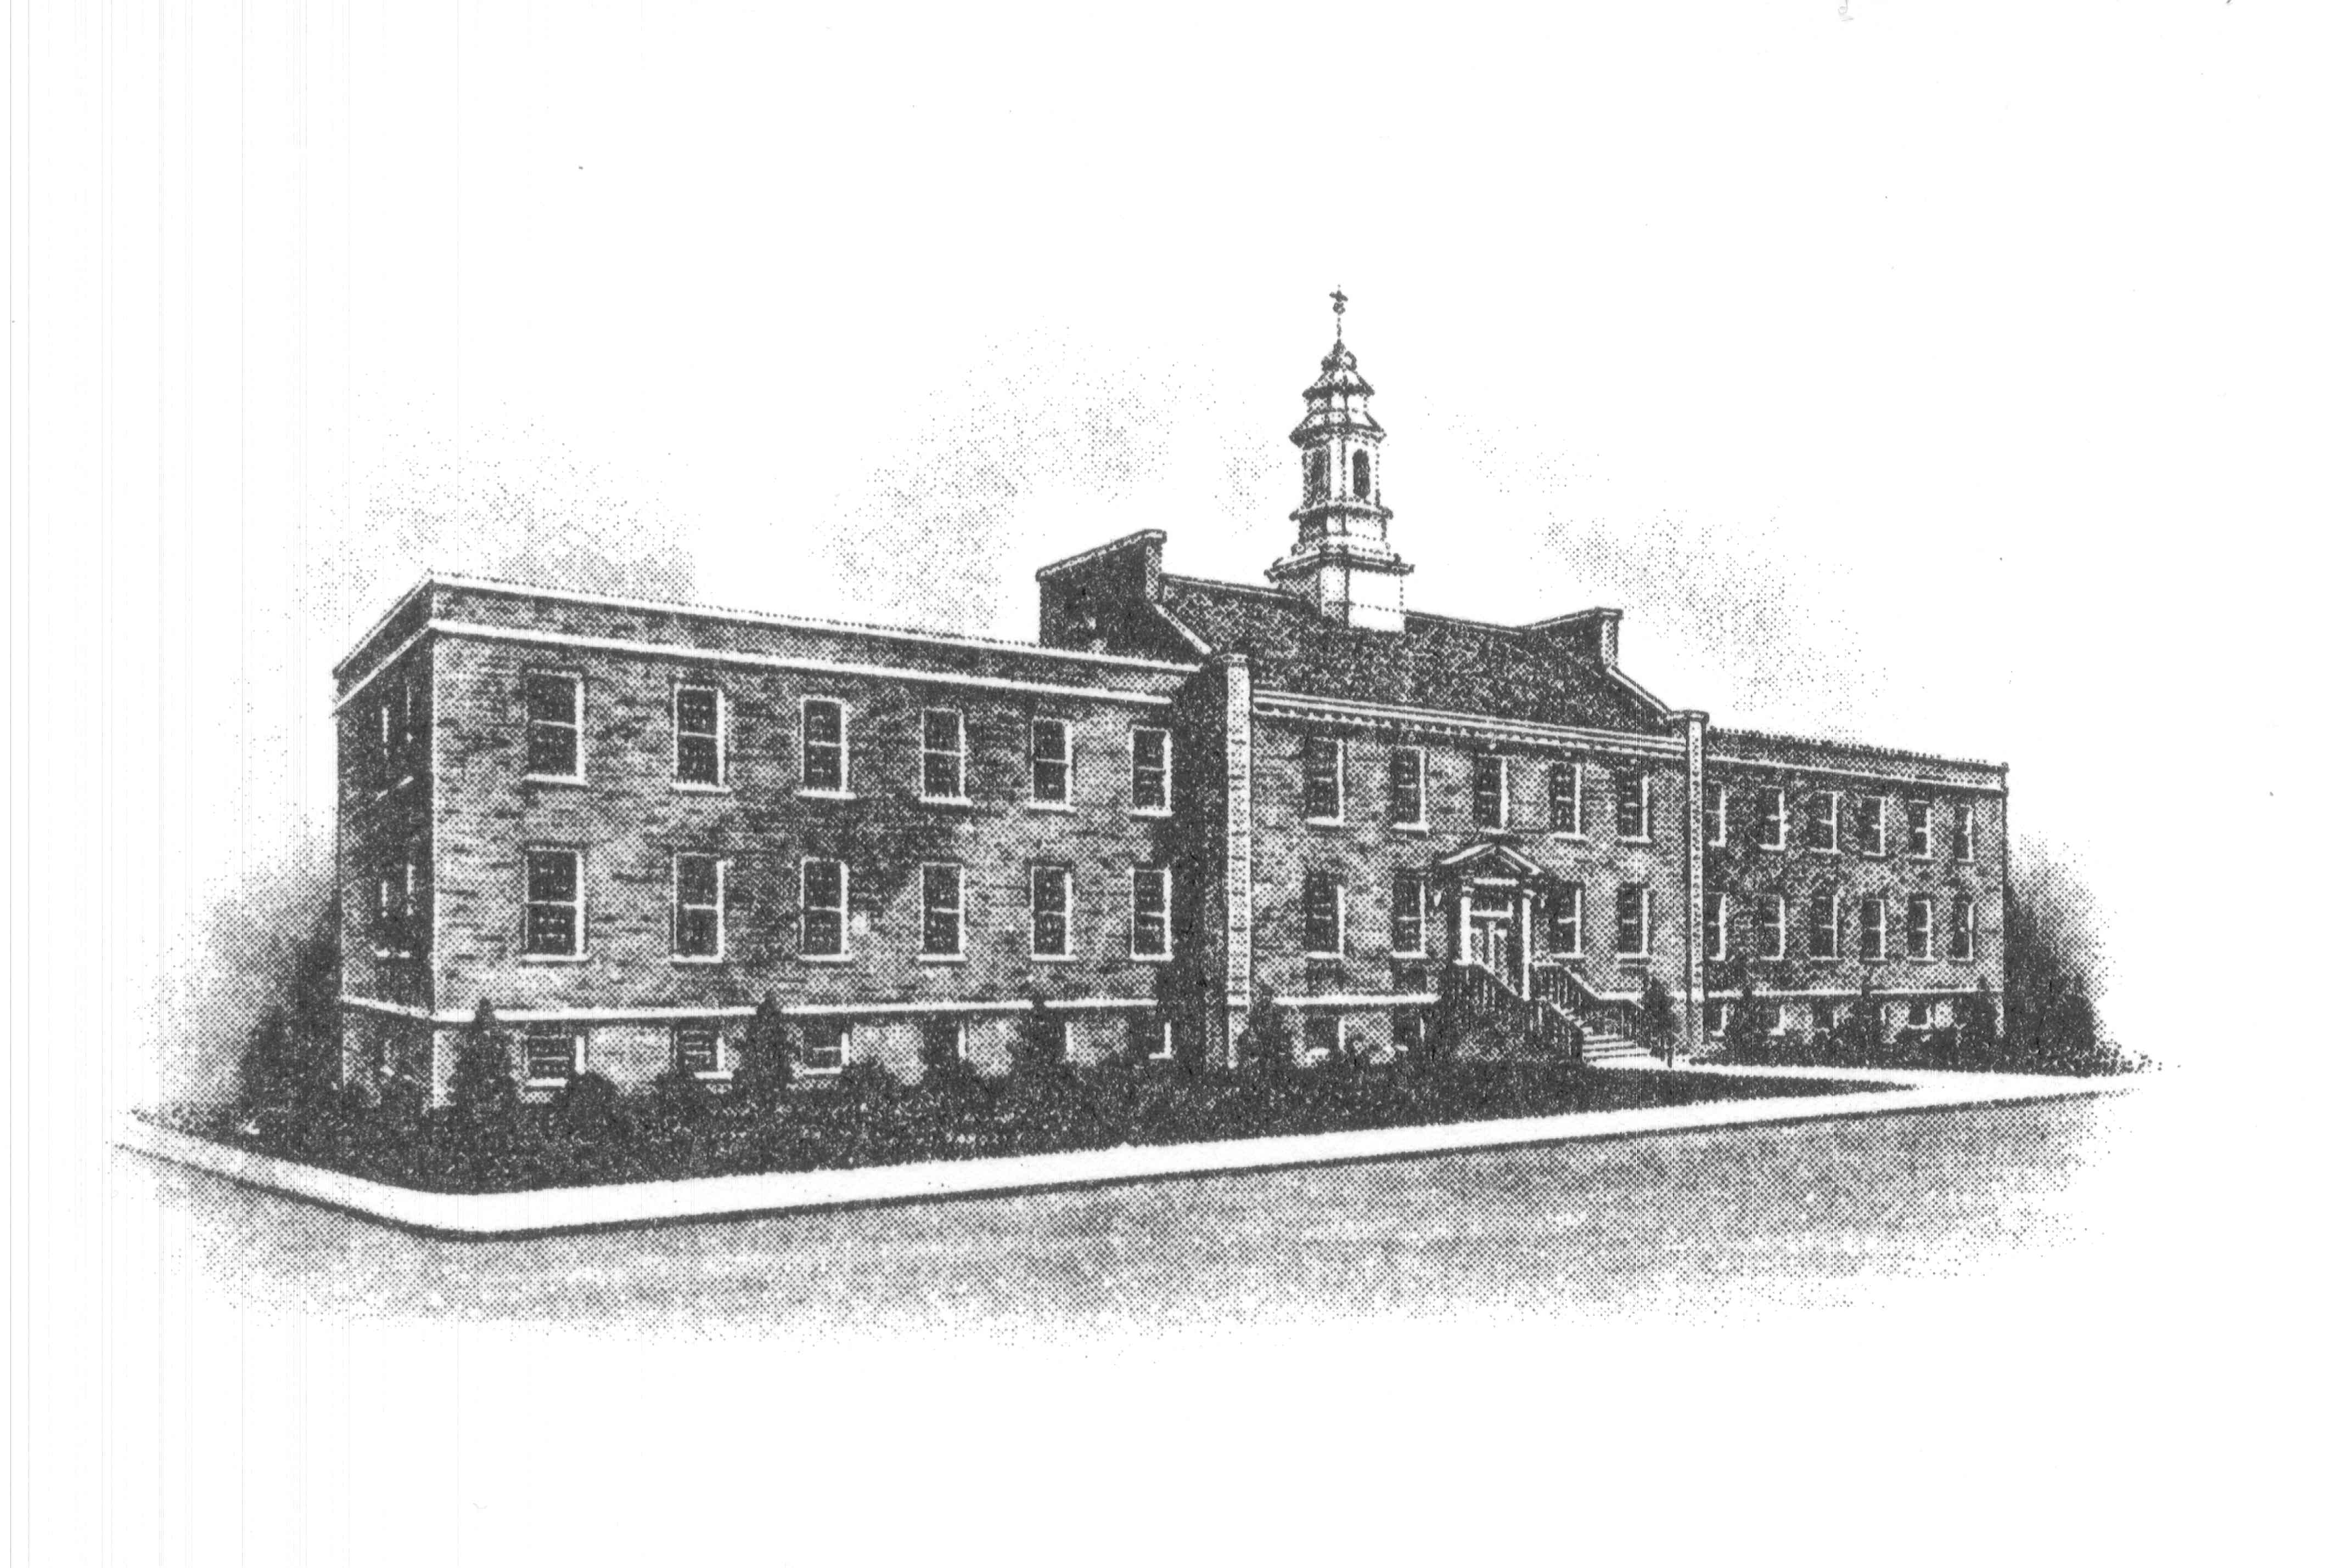
The Borough of Sayreville
Sayreville Economic & Redevelopment Agency
167 Main Street
Sayreville, NJ 08872
(732) 390-7077 - Phone

MEETING CANCELLATION

Please take notice that the Sayreville Economic & Redevelopment Agency (SERA) in the Borough of Sayreville, N.J. has cancelled its Thursday, March 26, 2020 meeting. Any matters which were to be heard and/or discussed on March 26, 2020, are hereby adjourned to Thursday, April 23, 2020 at 6:00 PM.

This meeting is being canceled as a public health and safety precaution due to the spread of the COVID-19 Coronavirus. The Agency anticipates resuming normal meeting schedule as of the April 23, 2020 meeting; however, due to the uncertainty of this situation that meeting could be also canceled, and if so, another notice will be posted.

Thank you.

Joan M. Kemble
Secretary
Sayreville Economic & Redevelopment Agency (SERA)

